Macro Unit 3 Progress Check – College Board Questions
- Which of the following best describes the aggregate demand curve?
- It is a curve that shows the relationship between consumer spending and income.
- It is a curve that shows the amount of goods and services domestic consumers will buy from domestic and foreign firms.
- It is a curve that shows the level of spending by consumers, businesses, the government, and the foreign sector at different price levels.
- It is a curve that shows only the level of government spending at different price levels.
- It is a curve that shows the level of spending by all factors of production at different price levels.
- Which of the following explains the relationship between the price level and real output along the aggregate demand curve?
- At a lower price level, people need more money to spend and therefore deposit less money in banks, which lowers interest rates and increases real output.
- At a lower price level, the real value of savings decreases which causes an increase in spending.
- At a lower price level, domestic goods will become less expensive compared to foreign goods, which causes an increase in spending on domestic goods.
- At a lower price level, real incomes decrease which causes an increase in spending.
- At a lower price level, the purchasing power of consumers’ income decreases which causes an increase in spending.
- The government of Euroland is considering increasing government spending to avoid a recession. What is the most likely effect on aggregate demand in Euroland?
- There will be a movement along the AD curve to a lower real output.
- There will be a movement along the AD curve to a higher price level.
- There will be no change in the AD curve.
- There will be a leftward shift in the AD curve.
- There will be a rightward shift in the AD curve.
- Assume the marginal propensity to consume is 0.75. What will happen if government spending increases by $100 billion?
- Real output will increase by a maximum of $75 billion.
- Real output will increase by a maximum of $100billion.
- Real output will increase by a maximum of $175 billion.
- Real output will increase by a maximum of $300 billion.
- Real output will increase by a maximum of $400 billion.
- According to the expenditure multiplier, if the marginal propensity to consume is greater than zero, a one-dollar change in autonomous expenditures will result in which of the following?
- A one-dollar increase in government spending
- A greater-than-one-dollar increase in government spending
- A one-dollar increase in the production of goods and services
- A one-dollar increase in aggregate demand for goods and services
- A greater-than-one-dollar increase in aggregate demand for goods and services
- Using the disposable income and consumption data in the table above, calculate the value of the marginal propensity to consume (MPC) and the marginal propensity to save (MPS) .
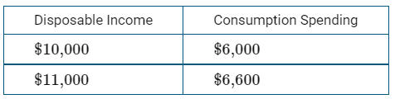
- MPC=0.04 , MPS=0.96
- MPC=0.10 , MPS=0.90
- MPC=0.20 , MPS=0.80
- MPC=0.50 , MPS=0.50
- MPC=0.60 , MPS=0.40
- In an economy where wages and prices are sticky, which of the following will happen as a result of an increase in the price level?
- There will be a downward movement along the short-run aggregate supply curve and real output will decrease.
- There will be an upward movement along the short-run aggregate supply curve and real output will increase.
- The short-run aggregate supply curve will shift to the right and real output will increase.
- The short-run aggregate supply curve will shift to the left and real output will decrease.
- The aggregate demand curve will shift to the right and real output will increase.
- The imposition by the United States of a tariff on imported steel from the European Union will likely have what impact on the short-run aggregate supply (SRAS) curve in the United States?
- It will cause a movement along the (SRAS) curve to a higher real output.
- It will cause a movement along the (SRAS) curve to a lower real output.
- It will have no impact on the (SRAS) curve.
- It will cause the (SRAS) curve to shift leftward.
- It will cause the (SRAS) curve to shift rightward.
- If nominal wages are fixed by labor contracts, then which of the following explains why the aggregate supply curve is upward sloping?
- A decrease in the price level will increase profits and production.
- A decrease in the price level will decrease profits and increase production.
- An increase in the price level will increase real wages and production.
- An increase in the price level will increase profits and production.
- An increase in the price level will decrease real wages and decrease production.
- Which of the following is illustrated by the long-run aggregate supply (LRAS) curve and the production possibilities curve (PPC) ?
- The multiplier effect
- The maximum sustainable capacity
- The trade-off between inflation and unemployment
- Sticky wages and prices
- Business cycles
- Suppose a nation opened its borders to the free flow of workers from other nations. How would this event likely affect the long-run aggregate supply (LRAS) curve and the production possibilities curve of the nation?
- The (LRAS) curve would shift to the right, and the production possibilities curve would not shift.
- Both curves would shift to the right.
- Neither curve would shift.
- Both curves would shift to the left.
- The (LRAS) curve would shift to the left, and the production possibilities curve would shift to the right.
- Suppose that the prices of labor and inputs to production are fixed in the short run but not in the long run. What is a consequence of this flexibility in the long run
- The long-run aggregate supply curve is vertical and there is no trade-off between inflation and unemployment in the long run.
- The long-run aggregate supply curve is vertical and there is a trade-off between inflation and unemployment in the long run.
- The long-run aggregate supply curve is horizontal and there is a trade-off between inflation and unemployment in the long run.
- Real output is always greater than full employment in the long run.
- Real output is always less than full employment in the long run.
- Which of the following is true about the equilibrium real output in the aggregate demand-aggregate supply (AD-AS) model in the short run?
- Equilibrium real output is always above full employment.
- Equilibrium real output is always below full employment.
- Equilibrium real output is always equal to full employment.
- Equilibrium real output can be above, equal to, or below full employment.
- Equilibrium real output is indeterminate.
- Which of the following accurately describes the state of the macro-economy if it is operating at the intersection of the AD1 and SRAS2 curves?
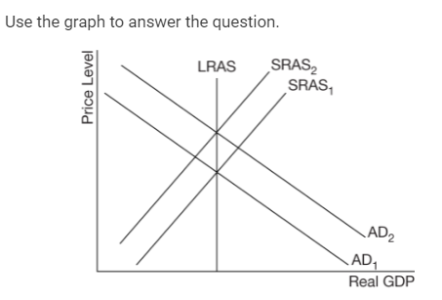
- It is operating at full employment and is in both a short-run and long-run equilibrium.
- It is operating above full employment and is in both a short-run and long-run equilibrium.
- It is operating below full employment and is in a short-run but not a long-run equilibrium.
- It is not in short-run equilibrium because output is below full employment.
- It is in long-run equilibrium because the economy is at full employment.
- Which of the following is true when an economy is operating at the intersection of the AD2 and SRAS2 curves?
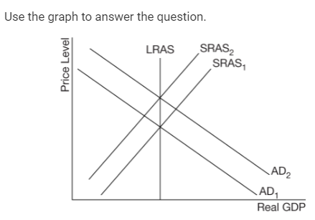
- The economy is facing a recessionary gap.
- The economy is facing an inflationary gap.
- The natural rate of unemployment is less than the actual unemployment rate.
- The natural rate of unemployment is greater than the actual unemployment rate.
- The economy is in short-run and long-run equilibrium.
- Assume that stock prices and home values have increased, raising household wealth. At the same time, productivity increased due to new technology. What is the likely short-run impact on the economy?
- The aggregate demand (AD) curve shifts right and the short-run aggregate supply (SRAS) curve shifts left, resulting in a higher price level and no change in the output level.
- The aggregate demand (AD) curve shifts left and the short-run aggregate supply (SRAS) curve shifts right, resulting in a lower price level and no change in the output level.
- The aggregate demand (AD) curve shifts right and the short-run aggregate supply (SRAS) curve shifts left, resulting in a higher output level and lower price level.
- Both the aggregate demand (AD) and the short-run aggregate supply (SRAS) curves shift right, resulting in a higher output level and indeterminate price level.
- Both the aggregate demand (AD) and the short-run aggregate supply (SRAS) curves shift right, resulting in a lower output level and indeterminate price level.
- Assume the economy of Country A is in long-run equilibrium. Which of the following will happen in the short run in Country A if one of its major trading partners, Country B, experiences a recession?
- Aggregate demand will increase and the price level will increase.
- Aggregate demand will decrease and the price level will decrease.
- Short-run aggregate supply will decrease and the price level will decrease.
- Short-run aggregate supply will increase and the price level will increase.
- Short-run aggregate supply will decrease and the price level will increase.
- Country X is currently in long-run macroeconomic equilibrium. If the country’s economy experiences a significant increase in the price of energy, a major input in production, which of the following will occur in the short run?
- The aggregate demand curve will shift to the left, and the actual rate of unemployment will exceed the natural rate of unemployment.
- The aggregate demand curve will shift to the left, and there will be an inflationary gap.
- The short-run aggregate supply curve will shift to the left, and the actual rate of unemployment will exceed the natural rate of unemployment.
- The short-run aggregate supply curve will shift to the left, and the price level will fall.
- The short-run aggregate supply curve will shift to the left and cause an inflationary gap.
- Assume an economy is currently at full employment. Which of the following best describes the long-run adjustments that will occur in the economy following a negative aggregate demand shock with no government intervention?
- Short-run aggregate supply will decrease, offsetting the initial aggregate demand shock and restoring full employment in the long run.
- The aggregate demand shock will result in a multiplier effect on real output moving the economy farther away from full employment in the long run.
- The price level will decrease and aggregate demand will increase until full employment is restored in the long run.
- Nominal wages will decrease and short-run aggregate supply will increase until full employment is restored in the long run.
- Real income will decrease and consumption spending will decrease moving the economy farther away from full employment in the long run.
- Suppose that the economy is in a recession. In the absence of government policy action to restore the economy to full employment, how will the economy adjust in the long run? 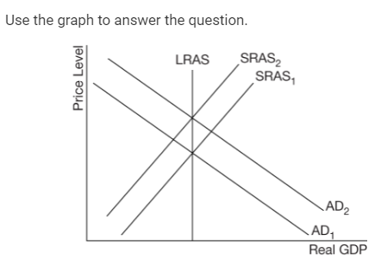
- The SRAS1 curve shifts to the left as nominal wages decrease and full employment is restored.
- The SRAS1 curve shifts to the right as nominal wages increase and full employment is restored.
- The SRAS2 curve shifts to the left as nominal wages increase and full employment is restored.
- The SRAS2 curve shifts to the right as nominal wages decrease and full employment is restored.
- The AD2 curve shifts to the left as nominal wages decrease and full employment is restored.
- If the natural rate of unemployment exceeds the actual rate of unemployment, which of the following will occur in the long run in the absence of government intervention?
- There will be cyclical unemployment.
- Input prices will decrease.
- Nominal wages will increase.
- The aggregate demand curve will shift to the left.
- The short-run aggregate supply curve will shift to the right.
- Suppose an economy is operating above full employment. Which of the following fiscal policy actions and resulting changes in aggregate demand will move the economy back towards full employment?
- Increasing government spending, which will shift the AD curve rightward.
- Decreasing government spending, which will shift the AD curve rightward.
- Increasing taxes, which will shift the AD curve leftward.
- Decreasing taxes, which will shift the AD curve leftward.
- Increasing transfer payments, which will shift the AD curve leftward.
- Which of the following represents an appropriate fiscal policy for the given economic conditions?
- An expansionary fiscal policy is appropriate to reduce unemployment when there is an inflationary gap.
- An expansionary fiscal policy is appropriate to reduce inflation when there is a recessionary gap.
- An expansionary fiscal policy is appropriate to reduce inflation when there is an inflationary gap.
- A contractionary fiscal policy is appropriate to reduce unemployment when there is a recessionary gap.
- A contractionary fiscal policy is appropriate to reduce inflation when there is an inflationary gap.
- The government of Olympia is considering a fiscal policy action to slow the economy and curb inflation. If the marginal propensity to consume is 0.8, which of the following responses correctly identifies a policy action that would help the government achieve its goals and the impact of that action on Olympia’s real gross domestic product (GDP) ?
- Increasing taxes by $10 billion increases real GDP by a maximum of $50 billion.
- Decreasing taxes by $10 billion decreases real GDP by a maximum of $50 billion.
- Increasing taxes by $10 billion increases real GDP by a maximum of $40 billion.
- Increasing government spending by $10 billion increases real GDP by a maximum of $50 billion.
- Decreasing government spending by $10 billion decreases real GDP by a maximum of $50 billion.
- What is an automatic stabilizer?
- It is a program or policy that counteracts the business cycle with discretionary fiscal policy.
- It is a program or policy that counteracts the business cycle without any new government action required.
- It is a tax or spending program that is enacted to balance the federal budget.
- It is the change in consumption spending resulting from a given change in disposable income.
- It is a part of a market economic system that ensures that markets achieve equilibrium in the long run.
- Which of the following best explains how income taxes can moderate a business cycle during an expansion?
- Tax payments increase automatically as gross domestic product (GDP) rises, which dampens consumption spending.
- Tax payments decrease automatically as GDP rises, which increases short-run aggregate supply.
- Tax payments increase automatically as GDP falls, which decreases short-run aggregate supply.
- Tax payments increase automatically as GDP falls, which prevents the economy from experiencing a downturn.
- Tax payments decrease automatically as GDP falls, which encourages consumption spending.
- How will automatic stabilizers affect the economy during a recession?
- They will shift the aggregate demand curve to the right, increasing real output.
- They will shift the aggregate demand curve to the left, decreasing real output.
- They will shift the long-run aggregate supply curve to the right, increasing potential output.
- They will shift the short-run aggregate supply curve to the left, increasing real output.
- They will shift the short-run aggregate supply curve to the right, decreasing real output.

Answers
1 | C | 11 | B | 21 | C
2 | C | 12 | A | 22 | C
3 | E | 13 | D | 23 | E
4 | E | 14 | C | 24 | E
5 | E | 15 | E | 25 | B
6 | E | 16 | D | 26 | A
7 | B | 17 | B | 27 | A
8 | D | 18 | C
9 | D | 19 | D
10 | B | 20 | D

